***Florida International University***

***School of Computing and Information Sciences***

**Feature**

**Document**

**User Story #872**

**Team Member:** April Perry

**Product Owner(s)​:** Gummi Traustason

**Mentor(s)​:** Masoud Sadjadi

**Instructor​:** Masoud Sadjadi

**User Story #872 --** “View graphical representation of STATISTICS”

* As a PLAYER, I would like the ability to see the graphical statistics of games that I have played, so that I can easily visualize my progress and easily track trends and/or patterns in my play.

### Acceptance Criteria:

1. User must be logged in
2. User must have played a game
3. User must have saved data from game

**Use Case**

1. “View graphical representation of STATISTICS”

Participating Actors: Player

Entry Condition: User wishes to view graphs representing the stats of their SkillCourt games so far

Events Flow:

1. Player clicks “View History” button on main dashboard
2. Player can scroll up and down to view different real time graphs

### Use Case Diagram

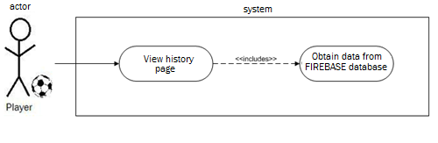

### Sequence Diagram

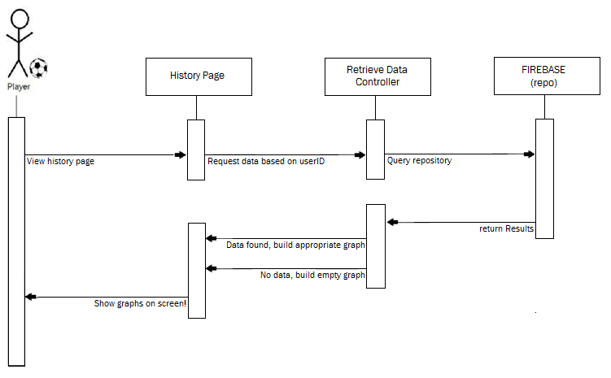

### Class Diagram

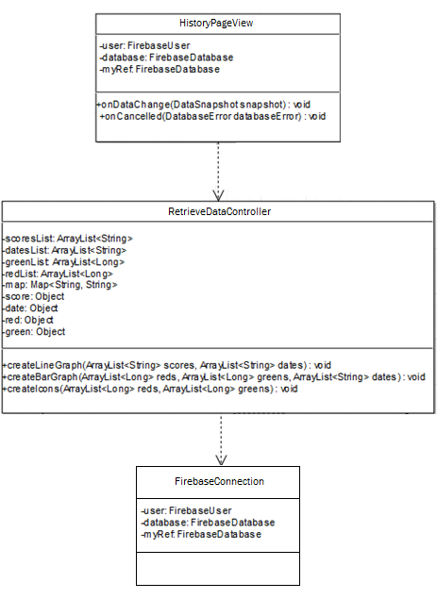

### Unit and Integration Testing

**Test Case 1**

○ *Purpose:* Test that the newly formatted “History” page is  
 clickable via the Main Dashboard

○ *Precondition:* User is logged in and clicks “History” button on  
 Main Dashboard page

○ *Expected Result:* The new general “History” page pops up and the  
 graph is created.

○ *Actual Result:* Same as expected.

○ *Status:* **PASS**

**Test Case 2**

○ *Purpose:* Test the scroll ability of the page

○ *Precondition:* User is already inside the “History” page and

scrolls down

○ *Expected Result:* The new general “History” page pops up and the  
 graph is created.

○ *Actual Result:* Same as expected.

○  *Status:* **PASS**

**Visual Diagram(s)**

*(Graphs with fake data below – real time retrieval will occur within “User Story #896”)*

